PCTURES OF JOINT INVESTIGATION VISIT TO OANDO ENERGY RESOURCES LIMITED FACILITY AT 18” TEBIDABA/BRASS PIPELINE, MGBIKIBA, SILGA BAYELSA STATE ON 27TH SEPTEMBER, 2024.
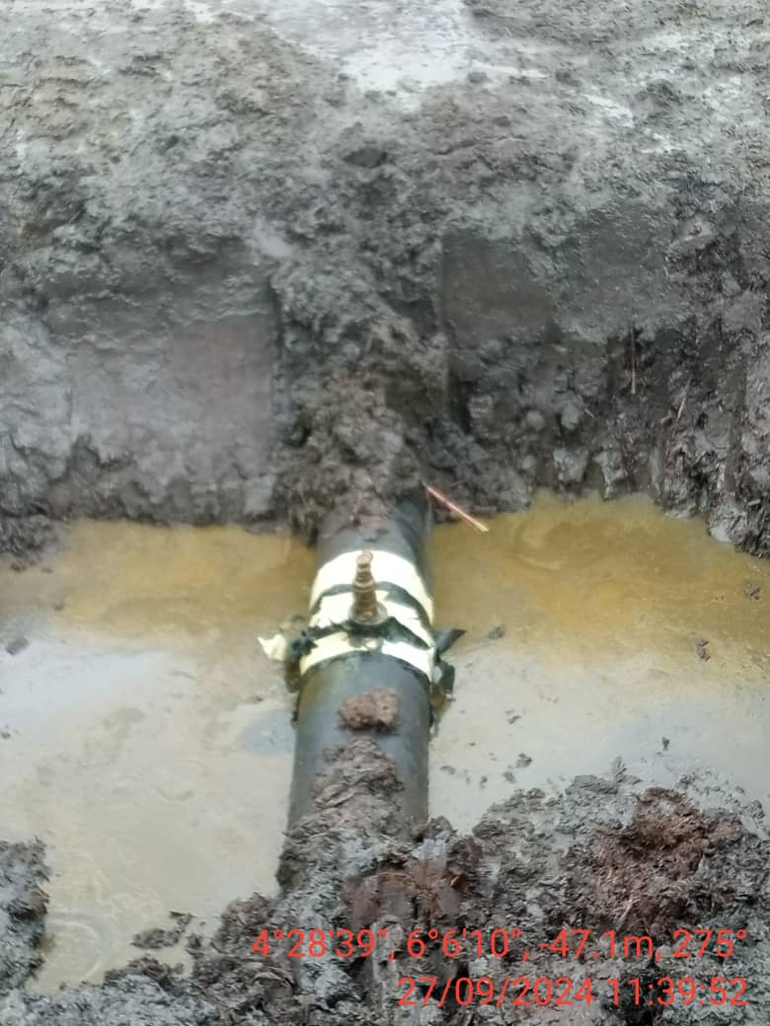
FIG. 1: 3” VALVE INSTALLED AT 12 O’ CLOCK POSITION BY UNKNOWN PERSON(S).
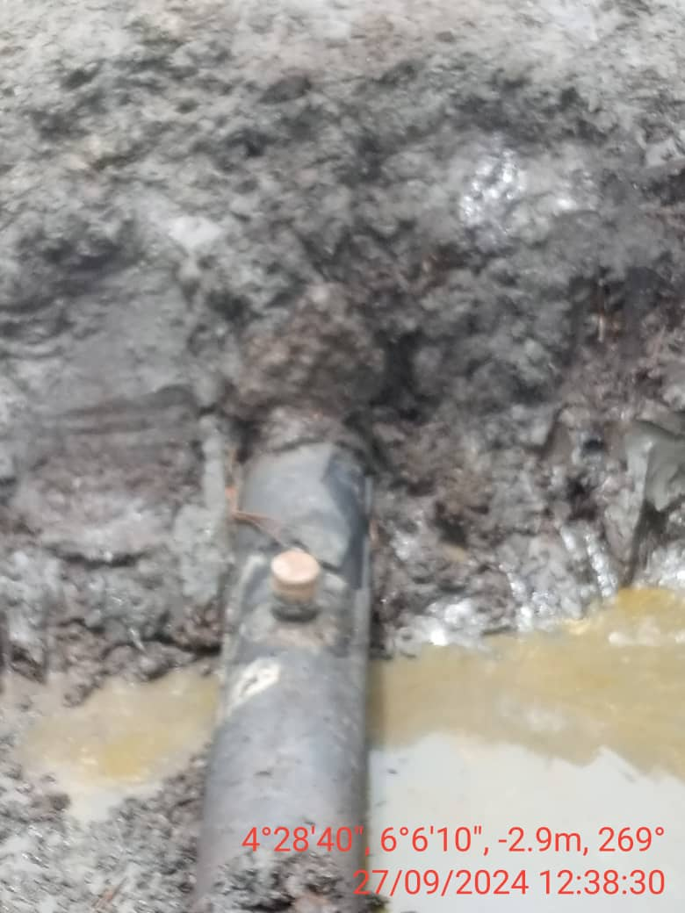
FIG. 2: THE INCIDENT POINT AFTER REPAIRS.

